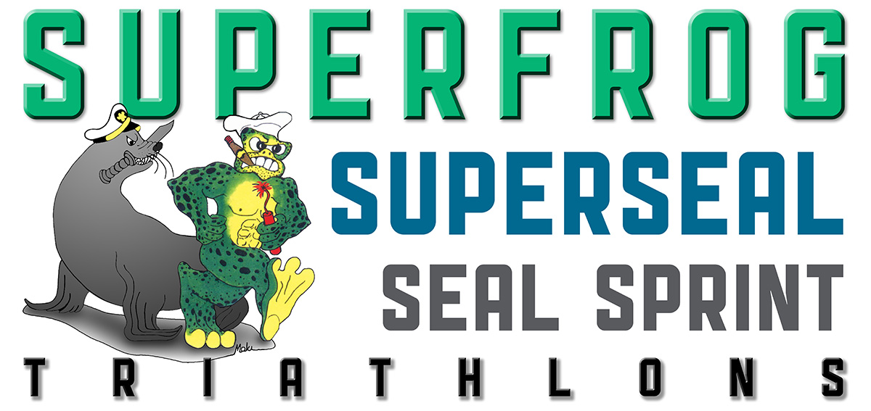

SUPERFROG, TRIDENT 4 MILER, AND F-1 RACE – SEPTEMBER 27-30, 2012

INDIVIDUAL VOLUNTEER APPLICATION

VOLUNTEER NAME___________________________________________________________________________

Contact Email:_____________________________________________ Your Age: _____ Your Gender: ______

Street Address:_____________________________________City:____________ _____ State:___ Zip:_ _____

Cell Phone: (____)___________ ______________ Alternative Phone: (____)____________________________

HAVE YOU VOLUNTEERED BEFORE? YES NO

IF YES, HOW MANY TIMES?_________________________________________________

T-SHIRTS ARE ADULT SIZES. PLEASE INDICATE YOUR PREFERRED SIZE SMALL MEDIUM LARGE XL XXL

Indicated the days/times you are available

____ FRIDAY, SEPTEMBER 28

____ SATURDAY, SEPTEMBER 29

____ SUNDAY SETEMBER 30

**IF YOU ARE AVAILBLE FOR A LONGER OR SHORTER AMOUNT OF TIME TO VOLUNTEER, PLEASE CALL OR EMAIL Callie Martin AT callie.kalani@gmail.com or (619) 818-7628.

September 28 is the Course Set up, Setember 29 is the Trident 4 Miler, F-1 races (both jr and sr), and the EXPO, and Sunday is SUPERFROG TRIATHLON.

Please fill out this form, as well as the form on the ACTIVE WEBSITE. Any questions/comments you may email Callie @ callie.kalani@gmail.com.

