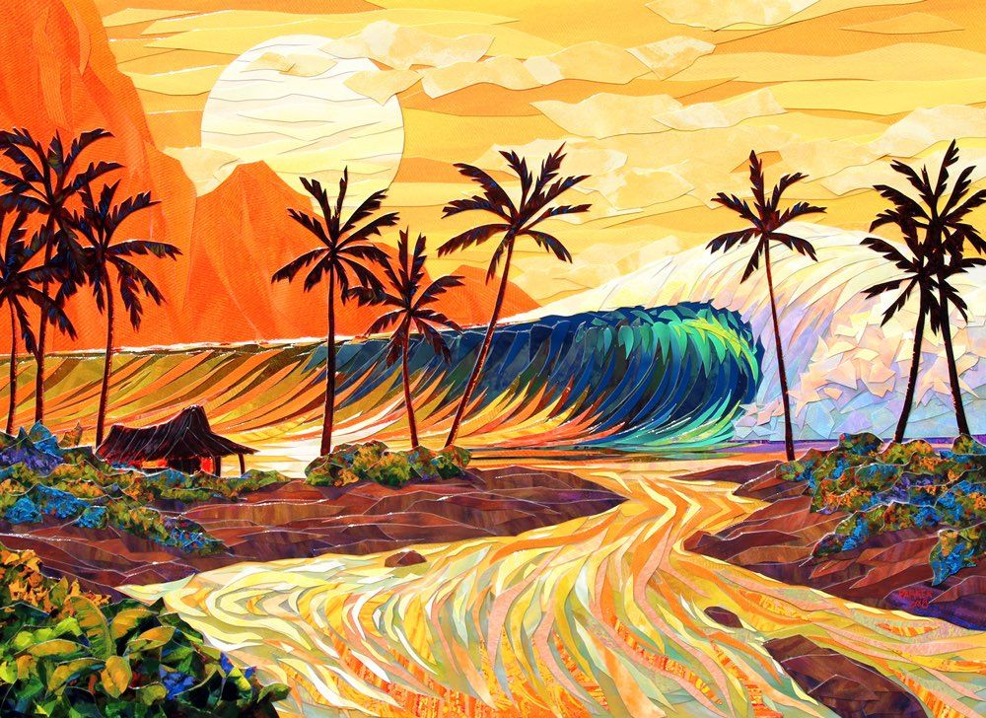

LANCE MANN GOES SURFING

By Samuel H. Blair

Artwork by Doug Mann

Lance Mann wakes up and drinks a hot cup of black coffee. Pg.1

Lance rides his yellow bike to check the waves.

Lance takes several deep breathes and enjoys the view.

Lance puts wax on his board and gets ready.

Lance paddles out to the big waves.

Lance surfs and surfs… and surfs to his heart’s content.

Lance walks back to his back on the way he gives out high fives.

Lance rinses his gear at home before taking a hot shower.

Lance makes a healthy dinner, and a fire.

Lance sits in his cozy chair after dinner reading a big book.

Lance eats a mud pie, his favorite dessert. Mud Pie consists of chocolate and coffee ice cream, layered on an Oreo crust.

Lance smiles and says “it’s been an awesome (a bitchin) day!”