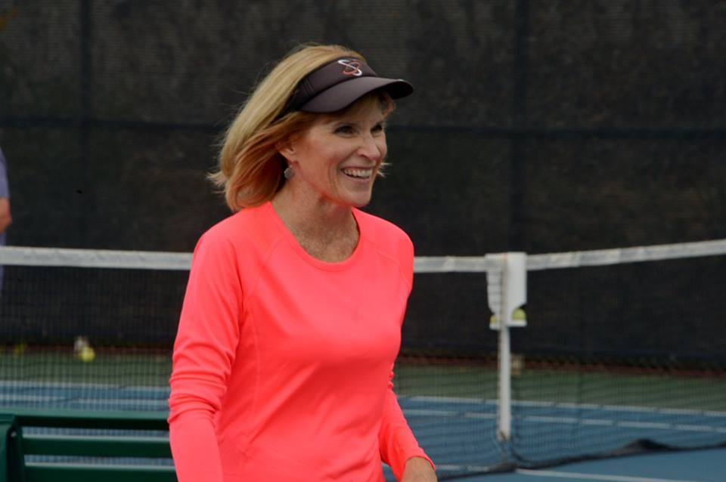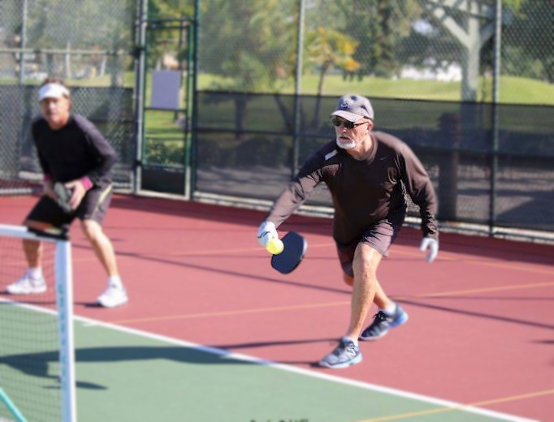

# **Beginner/Advanced Beginner: 4:15-5:15pm**

# **Paddles and balls provided/Maximum 12 students**

# **Residents: $12/Non-Residents: $14**

# **Call the Coronado Tennis Center**

# **RESERVE YOUR SPOT NOW: 619-522-2650**

# **Clinic Location:**

# **High School Courts: 555 D Street**

# **Coronado Teaching Pro: Michael Fraser Coronado Pickleball Contact: Tammy Carney**

CORONADO

PICKLEBALL CLINICS

NEXT CLINIC:

SATURDAY,

JULY 9