 HELP US SAVE A WOMAN’S LIFE!

Ovarian Cancer is no longer the “silent killer”! There ARE symptoms! There ARE risk factors!! However, there is no test for the early detection of this disease…your symptoms may be the only clue that something is wrong!!

Thanks to the Soroptimist International of Coronado’s generous Best for Women Grant, please join us for this presentation and become aware of these symptoms and risk factors by attending a presentation on October 21st, the Coronado Senior Center. You will hear amazing inspirational stories from ovarian cancer survivors, and you will learn information that can save your life or the life of a woman you love.

HEAR is an innovative program of the Ovarian Cancer Alliance of San Diego (OCA) called “HEAR: Ovarian Cancer: If only I knew then what I know Now.”
H: Hope
E: Experiences
A: Awareness
R: Risks

This program is designed to spread awareness about ovarian cancer throughout San Diego County. Our goal is to reach and empower women to be aware of their bodies and to inform them about the importance of the early detection of ovarian cancer. Light snacks and drinks will be provided.

When: October 21st, 2015

Where: Coronado Senior Center
1019 7th Street
Coronado, CA 92118

Contact: Berie Grobe Deberie@hotmail.com

Time: 10:30 a.m. - 11:30 a.m.
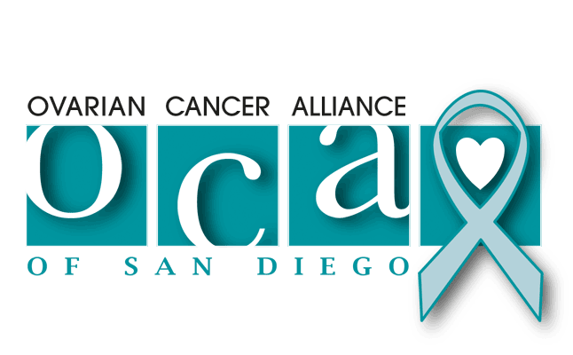

Please visit our website at www.ocaofsd.org

